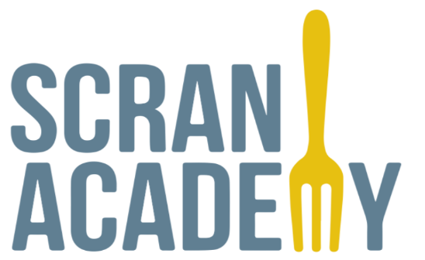
Scran Academy Privacy Policy
This privacy policy will explain how Scran Academy SCIO uses the personal data we collect from you when you use our website.
Topics:
- What data do we collect?
- How do we collect your data?
- How will we use your data?
- How do we store your data?
- Marketing
- What are your data protection rights?
- What are cookies?
- How do we use cookies?
- What type of cookies do we use?
- How to manage your cookies
- Privacy policies of other websites
- Changes to our privacy policy
- How to contact us
- How to contact the appropriate authorities
What data do we collect?
Scran Academy SCIO collects the following data:
- Personal identification information (Name, Address, Email Address, Phone Number)
How do we collect your data?
You directly provide Scran Academy SCIO with the data we collect. We collect data and process data when you:
- Register online or place an order for any of our products or services.
- Complete an online registration form.
- Sign up to be a member of our website.
- Voluntarily complete a customer survey or provide feedback via email.
- Use or view our website via your browser’s cookies.
How will we use your data?
Scran Academy SCIO collects your data so that we can:
- Process your order, manage your account.
- Email you with special offers on other products and services we think you might like.
If you agree, Scran Academy SCIO will share your data with our partner organisations to provide the Scran Meals Coalition project.
- Pilton Equalities Project
- Edinburgh Academy
- HCL Transport
When Scran Academy SCIO processes orders, it may send your data to and also use the resulting information from, credit reference agencies to prevent fraudulent purchases.
How do we store your data?
Scran Academy SCIO securely stores your data on our secure online database and/or in locked filing cabinets in our office at 122 Crewe Road South, EH4 2NY.
Scran Academy SCIO will keep your data for two years. Once this time period has expired, we will delete your data from our database and shred any physical records/copies.
Marketing
Scran Academy SCIO would like to send you information about products and services of ours that we think you might like.
If you have agreed to receive marketing, you may always opt out at a later date.
You have the right at any time to stop Scran Academy SCIO from contacting you for marketing purposes.
If you no longer wish to be contacted for marketing purposes, please click here.
What are your data protection rights?
Scran Academy SCIO would like to make sure you are fully aware of all of your data protection rights. Every user is entitled to the following:
The right to access – You have the right to request Scran Academy SCIO for copies of your personal data. We may charge you a small fee for this service.
The right to rectification – You have the right to request that Scran Academy SCIO correct any information you believe is inaccurate. You also have the right to request Scran Academy SCIO to complete information you believe is incomplete.
The right to erasure – You have the right to request that Scran Academy SCIO erase your personal data, under certain conditions.
The right to restrict processing – You have the right to request that Scran Academy SCIO restrict the processing of your personal data, under certain conditions.
The right to object to processing – You have the right to object to Scran Academy SCIO’s processing of your personal data, under certain conditions.
The right to data portability – You have the right to request that Scran Academy SCIO transfer the data that we have collected to another organisation, or directly to you, under certain conditions.
If you make a request, we have one month to respond to you. If you would like to exercise any of these rights, please contact us at hello@scranacademy.com
What are cookies?
Cookies are text files placed on your computer to collect standard Internet log information and visitor behaviour information. When you visit our website, we may collect information from you automatically through cookies or similar technology.
For further information, visit allaboutcookies.org
How do we use cookies?
Scran Academy SCIO uses cookies in a range of ways to improve your experience on our website, including:
- Keeping you signed in
- Understanding how you use our website
What types of cookies do we use?
There are a number of different types of cookies, however, our website uses:
- Functionality – Scran Academy SCIO uses these cookies so that we recognise you on our website and remember your previously selected preferences. These could include what language you prefer and location you are in. A mix of first-party and third-party cookies are uses.
How to manage cookies
You can set your browser not to accept cookies, and the above website tells you how to remove cookies from your browser. However, in a few cases some of our website features may not function as a result.
Privacy policies of other websites
The Scran Academy SCIO website contains links to other websites. Our privacy policy applies only to our website, so if you click on a link to another website, you should read their privacy policy.
Changes to our privacy policy
Scran Academy SCIO keeps its privacy policy under regular review and places any updates on this web page. This privacy policy was last updated on 4 May 2020.
How to contact us
If you have any questions about Scran Academy SCIO’s privacy policy, the data we hold on you, or your would like to exercise one of your data protection rights, please do not hesitate to contact us.
Email us at: hello@scranacademy.com
How to contact the appropriate authority
Should you wish to report a complaint or if you feel that Scran Academy SCIO has not addressed your concern in a satisfactory manner, you may contact the Information Commissioner’s Office.
Email: scotland@ico.org.uk
Phone: 0303 123 1115
Address: The Information Commissioner’s Office – Scotland
45 Melville Street,
Edinburgh,
EH3 7HL

